**IT**

1. Class A
2. First address – 0.0.0.0 Last Address-127.255.255.255
3. Network Address-10.66.0.0
4. Host Id-0.0.6.169
5. 256
6. 10.66.6.255
7. 10.66.0.1 – 10.66.254.255
8. 2^16
9. 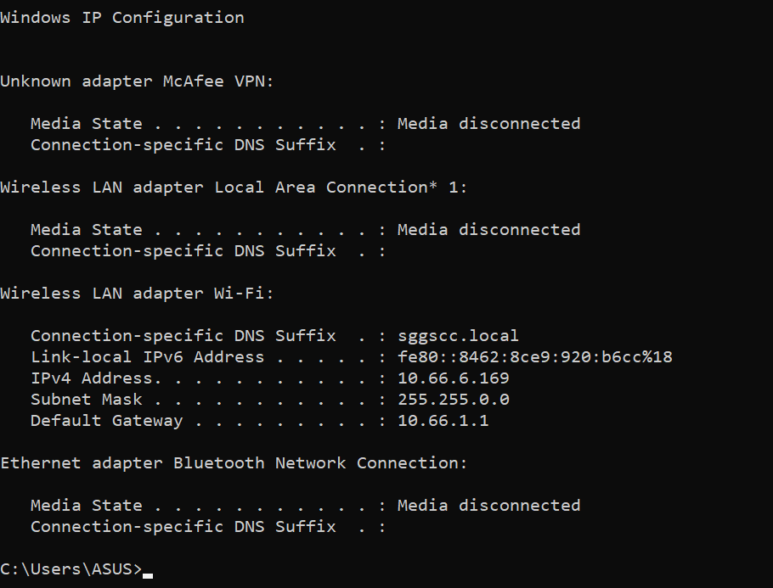15